Tweets Sentiment Analyzer
CAB432 Assignment 2

http://localhost:3000

Po Shing Chun – n9231081
Elizaveta Konovalova – n0000000

Table of Contents
1.0 Introduction 2
1.1 Description of the application 2
1.2 Services to be used 2
1.3 Development strategy 3
2.0 Technical Description 4
2.1 Sever Side 4
2.2 Client Side 5
2.3 Difficulties 5
3.0 Scaling and Performance 6
4.0 Test 7
4.1 Compromises 7
6.0 References 9
7.0 Appendix 10
Appendix A Brief user guide 10
Appendix B Deployment Instructions 10
Appendix C Test Screen Shots 11

1.0 Introduction

1.1 Description of the application
Tweets Sentiment Analyzer is a service for users to search keywords, specifying multiple “hash tags” that are manually emphasized by the tweets authors of Twitter users. Tweets messages related to those keywords will keep sending back to the application, after that, the application will perform sentiment analysis to examine those tweet messages whether are positive, negative or neutral. Base on the analyzed information, the result will be displayed on the screen in bar chart format. The graph will keep changing as the results will keep sending back the website until users press the stop button.

1.2 Services to be used
Twitter Streaming APIs
API URL Example:
https://stream.twitter.com/1.1/statuses/filter.json?track=twitter
Twitter npm URL: https://www.npmjs.com/package/twitter
The Twitter Streaming API can provide samples of the public data flowing through Twitter, after established a connection with a streaming endpoint, a feed of Tweets will be delivered (Twitter, 2016). Public status that matches one or more filter predicates which is users’ searching keywords will be returned. In addition, Twitter npm module is used to connect with Twitter Streaming API which is convenient and simple to use. It handles authentication and requests for Twitter Streaming API.

Retext-sentiment
Retext-sentiment URL: https://www.npmjs.com/package/retext-sentiment
Retext-sentiment is a npm module that automatically detects the sentiment of each text, sentence and returns the valence and polarity value (Wormer, 2016). The valence is either “neutral”, “positive” or “negative” and the polarity is a number between -5 and 5 (Wormer, 2016). This module is used to analyse the tweets message from Twitter Streaming API and provide results to the application in order to display the data.
D3.js
D3.js URL: https://d3js.org/
D3.js is a JavaScript library for manipulating document based on data, it helps user to visualize data using HTML, SVG and CSS (D3, 2016). D3 allows users to bind arbitrary data to a Document Object Model (DOM) and then apply data-driven transformation to the document (D3, 2016). For instance, D3 can generate an HTML table from an array of data or use the data to create an SVG bar chart (D3, 2016).

1.3 Development strategy
First, the requests and responses between client and server side were determined, such as GET request, socket connections. After that client and server were implemented at the same time. In client side, user interface with HTML, CSS and JavaScript is implemented and ready for sending users’ queries to the server side. In server side, requests to Twitter API are implemented and ready for sending sentiment analysis back to client side. Next, finalization is done to make the connections between server and client side in order to make the application working. Testing is followed to eliminate bugs as many as possible. Finally, the application is ready for deployment in the cloud.

2.0 Technical Description
This service is implemented mainly to send requests to Twitter Streaming API to retrieve Tweets message back to the server in order to process. The server and client side will not store any data for the application. A webpage is created to provide an end user interface for users. Server is used to process sentiment analysis and manipulate the data coming back from Twitter API server.

2.1 Sever Side
Express JS which sits on top of Node JS is used for the web server. Express is a minimal and flexible Node.js web application framework that provides lots of features for web and mobile application, also, Express provides a thin layer of fundamental web application component, therefore it has a good performance and easy to deploy (Express, 2016). A several Node modules are used for the server.
- Express JS (web application framework)
- HTTP (server-side HTTP requests)
- Twitter (client library for Twitter APIs)
- Retext-sentiment (sentiment analysis)
- Socket.IO (server-side socket connection)
The HTTP module is used to handle static file request such as index.html, JavaScript and CSS files. Socket.IO module is use to open a socket connection between client and server and listen for specific event occur. User will send a query through the socket and the server will use the socket to send a flow of sentiment analysis result to client which is kind of real-time analysis. The Twitter module is implemented to handle requests and responses between server and the Twitter Stream API which is convenient. Retext-sentiment module is used to analysis the tweets come back from the Twitter Stream API and provide the result, positive, negative or neutral.

2.2 Client Side
The website is presented by using HTML5 and CSS3, and dynamically generated by JavaScript with JQuery. JSON object data is keep returning to the client from server side through socket connection in order to display the sentiment analysis. There are several libraries are used in client side.
- Bootstrap (Styling)
- D3js – (data virtualization)
- Socket.IO – (client-side socket connection)
Bootstrap is used partly in the design of the HTML page, such as search bar and buttons which can provide professional look and feel. D3js library is used to virtualize the analysis data, showing in a bar chart format which is clear and simple. Socket.IO client side is implemented to establish a socket connection with server in order to listen and send events which is the same as server-side socket.IO module does.

2.3 Difficulties
The application skeleton is created by using express application generator which is well organized. But implementing a socket.IO module in the routes file needs to do a minor modification in the bin/www and app.js file which takes some time to do researches.
There is a rate limitation in the Twitter Streaming API, if user sends the same query to the Twitter Streaming API within a couple of minutes, error code 420 will be returned from the API which means that the client has connected too frequently.

3.0 Scaling and Performance

Possible Subtitles:
Image Template?
Scale Set/ Worker group?

4.0 Test
Test Plan
The screen shots are shown in Appendix C.
ID | Purposes | Expected/Actual | Pass | Screen Shot
1 | Search keywords no terms | E: No Results  A: No Results | Yes | 1.0
2 | Search keyword “trump” | E: Result shown, graph keep changing  A: Result shown, graph keep changing | yes | 2.0
3 | Search keyword “trump war” | E: Result shown, graph keep changing  A: Result shown, graph keep changing | yes | 3.0
4 | Press Stop button after search | E: Result shown, graph stop changing  A: Result shown, graph stop changing | Yes | 4.0
5 | Search keyword “facebook” after one search | E: Result shown, graph keep changing  A: Result shown, graph keep changing | Yes | 5.0
6 | Search keyword “Brisbane”  after stopped | E: Result shown, graph keep changing  A: Result shown, graph keep changing | Yes | 6.0
7 | Refresh the page when searching | E: No Result, Show home page  A: No Result, Show home page | Yes | 1.0

4.1 Compromises

???
5.0 Possible Extensions
To extend it further, I think there should be more sentiment analysis result, not just positive, negative and neutral. Moreover, users are capable of search multiple keywords and get multiple result simultaneously.

In client side, the presentation of the website can be improved to support mobile device so that the presentation of HTML elements will be changed based on the resolution of user browser.

6.0 References

D3. 2016. Overview. Retrieved October, 29, 2016 from https://d3js.org/
Express. 2016. Home Retrieved October 30, 2016 from http://expressjs.com/
Twitter. 2016. Twitter Developer Documentation, Public streams. Retrieved October 29, 2016 from https://dev.twitter.com/streaming/public
Wormer, T. 2016. retext-sentiment. Retrieved October 29, 2016 from https://www.npmjs.com/package/retext-sentiment

7.0 Appendix

Appendix A Brief user guide

Appendix B Deployment Instructions

Appendix C Test Screen Shots

1.0 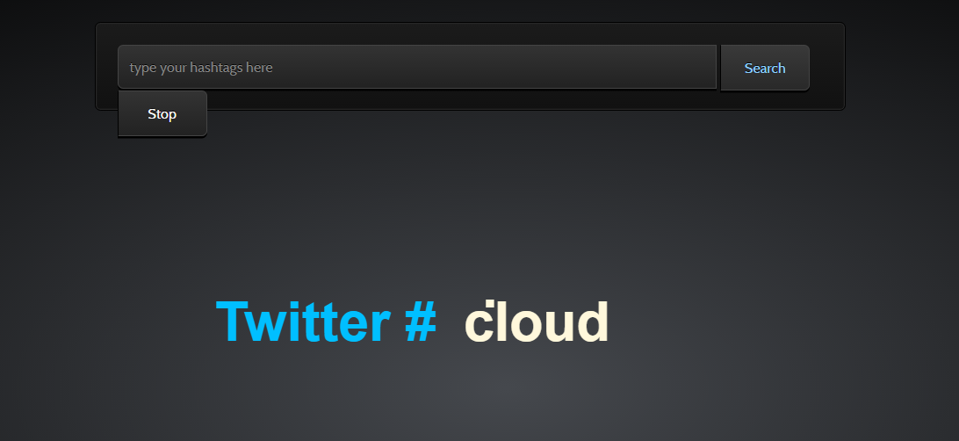

2.0
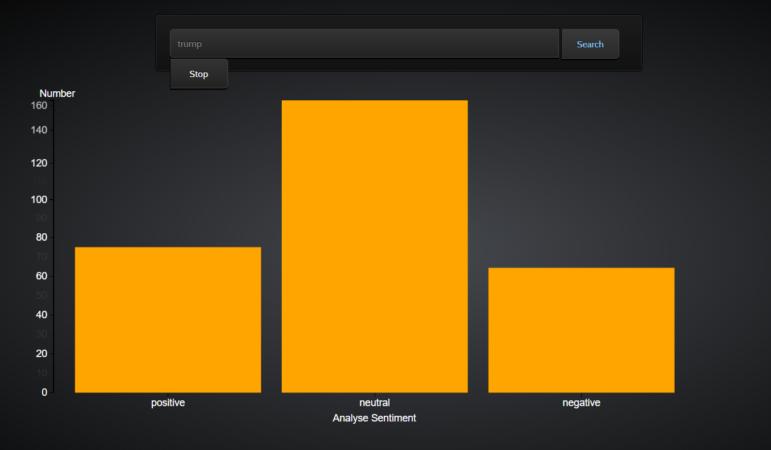
3.0
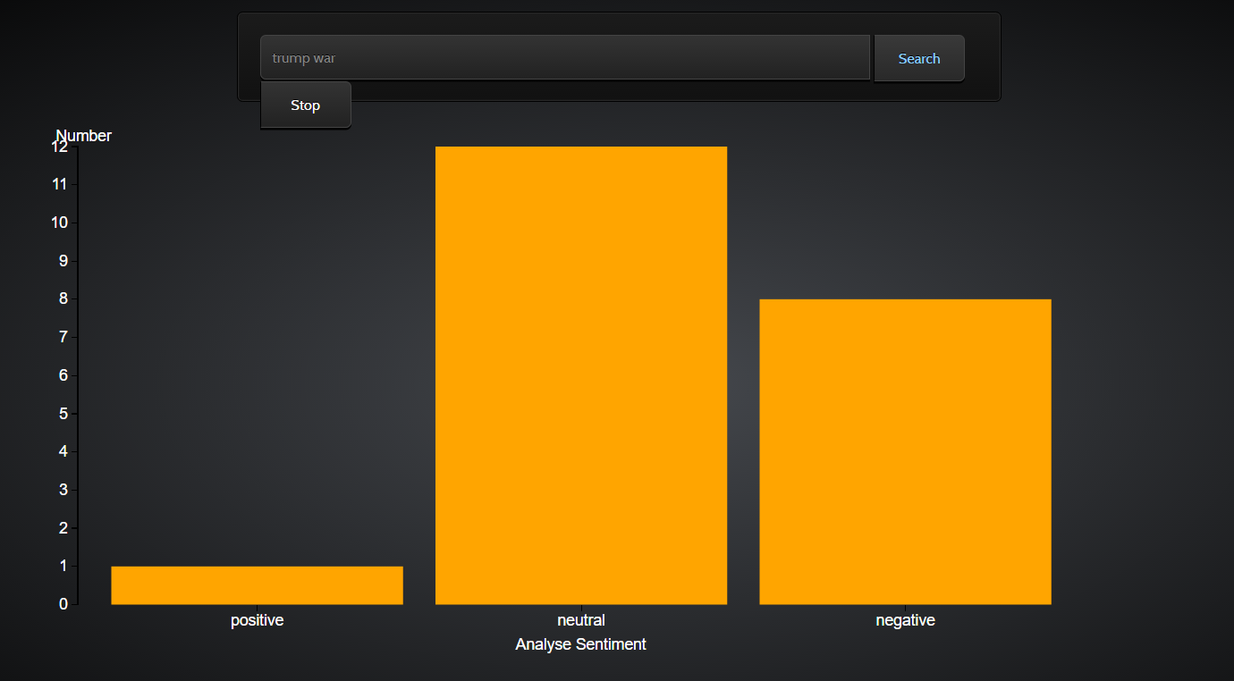
4.0
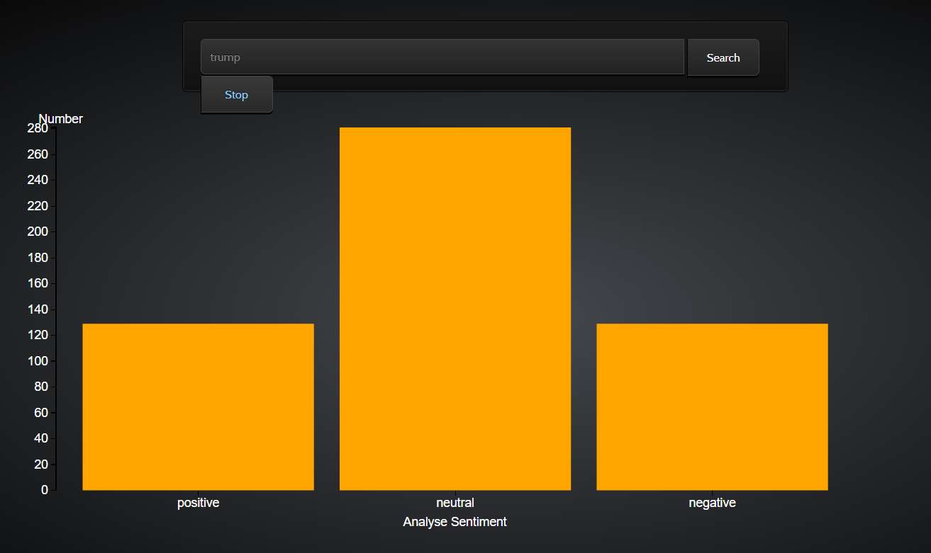
5.0
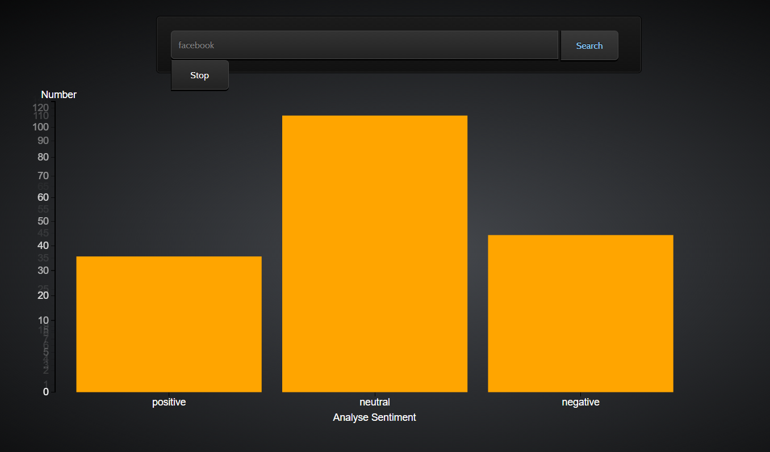
6.0
